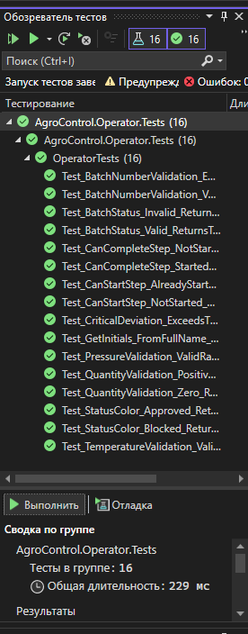
using Microsoft.VisualStudio.TestTools.UnitTesting;
using AgroControl.Operator;

namespace AgroControl.Operator.Tests
{
[TestClass]
public class OperatorTests
{
[TestMethod]
public void Test_BatchNumberValidation_Valid_ReturnsTrue()
{
bool isValid = TestHelpers.IsBatchNumberValid("B-2405-001");
Assert.IsTrue(isValid);
}

[TestMethod]
public void Test_BatchNumberValidation_Empty_ReturnsFalse()
{
bool isValid = TestHelpers.IsBatchNumberValid("");
Assert.IsFalse(isValid);
}

[TestMethod]
public void Test_BatchStatus_Valid_ReturnsTrue()
{
bool isValid = TestHelpers.IsValidBatchStatus("выполняется");
Assert.IsTrue(isValid);
}

[TestMethod]
public void Test_BatchStatus_Invalid_ReturnsFalse()
{
bool isValid = TestHelpers.IsValidBatchStatus("неизвестный");
Assert.IsFalse(isValid);
}

[TestMethod]
public void Test_CanStartStep_NotStarted_ReturnsTrue()
{
bool canStart = TestHelpers.CanStartStep("не начат");
Assert.IsTrue(canStart);
}

[TestMethod]
public void Test_CanStartStep_AlreadyStarted_ReturnsFalse()
{
bool canStart = TestHelpers.CanStartStep("выполняется");
Assert.IsFalse(canStart);
}

[TestMethod]
public void Test_CanCompleteStep_Started_ReturnsTrue()
{
bool canComplete = TestHelpers.CanCompleteStep("выполняется");
Assert.IsTrue(canComplete);
}

[TestMethod]
public void Test_CanCompleteStep_NotStarted_ReturnsFalse()
{
bool canComplete = TestHelpers.CanCompleteStep("не начат");
Assert.IsFalse(canComplete);
}

[TestMethod]
public void Test_TemperatureValidation_ValidRange_ReturnsTrue()
{
bool valid = TestHelpers.IsTemperatureValid(85.5m);
Assert.IsTrue(valid);
}

[TestMethod]
public void Test_PressureValidation_ValidRange_ReturnsTrue()
{
bool valid = TestHelpers.IsPressureValid(2.5m);
Assert.IsTrue(valid);
}

[TestMethod]
public void Test_QuantityValidation_Positive_ReturnsTrue()
{
bool valid = TestHelpers.IsQuantityValid(500m);
Assert.IsTrue(valid);
}

[TestMethod]
public void Test_QuantityValidation_Zero_ReturnsFalse()
{
bool valid = TestHelpers.IsQuantityValid(0);
Assert.IsFalse(valid);
}

[TestMethod]
public void Test_GetInitials_FromFullName_ReturnsCorrect()
{
string initials = TestHelpers.GetInitials("Зайцев Петр Николаевич");
Assert.AreEqual("ЗП", initials);
}

[TestMethod]
public void Test_CriticalDeviation_ExceedsThreshold_ReturnsTrue()
{
bool isCritical = TestHelpers.IsCriticalDeviation(100, 80, null, null, null, null);
Assert.IsTrue(isCritical);
}

[TestMethod]
public void Test_StatusColor_Approved_ReturnsGreen()
{
string color = TestHelpers.GetStatusColor("одобрена");
Assert.AreEqual("Green", color);
}

[TestMethod]
public void Test_StatusColor_Blocked_ReturnsDarkRed()
{
string color = TestHelpers.GetStatusColor("заблокирована");
Assert.AreEqual("DarkRed", color);
}
}
}

